**Assignment 19.2**

**Convert XML File into JSON File Format.**

**Input**

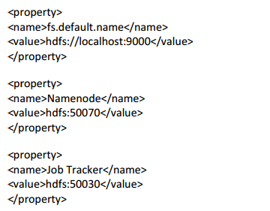

**Logic:**

**Step1:** Download the jar file to convert xml to Jason

**Step2:** Export the jar into your code and in share folder of Hadoop

**Step3:** In mapper, UseXML. toJSONobject() to convert XML to JSON and it will be written as Key and nullwritable as value.

**Working:**

**Step 3: Map Method for Converting XML to JSON Format:**

The **String xml_data** will read an XML record and converts it into a String using the toString() method.

This XML record is converted into JSON object using the ***XML.toJSONobject()*** method present in the jar file which we have added.

The obtained JSON object will be again converted into String using the toString() method.Since there is no value nullwritable is taken as value.

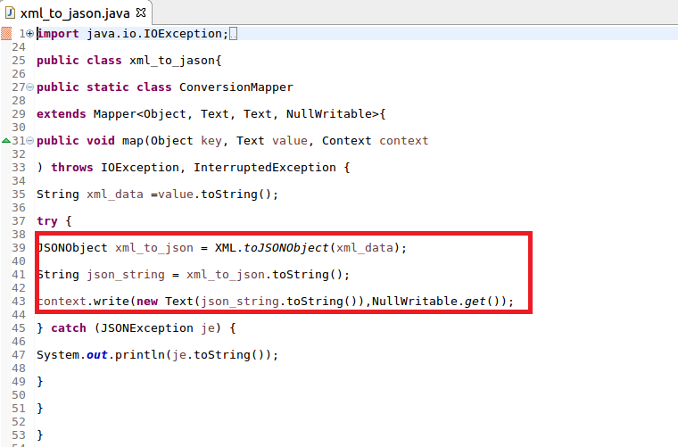

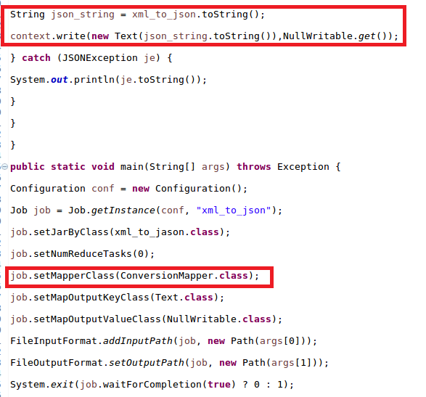

**Running jar:**

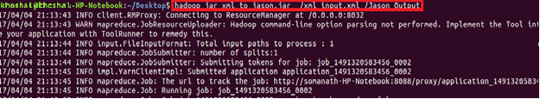

**Output:**

